Year 12 General Human Biology
Immunity

Task 3: Control of Infectious Diseases

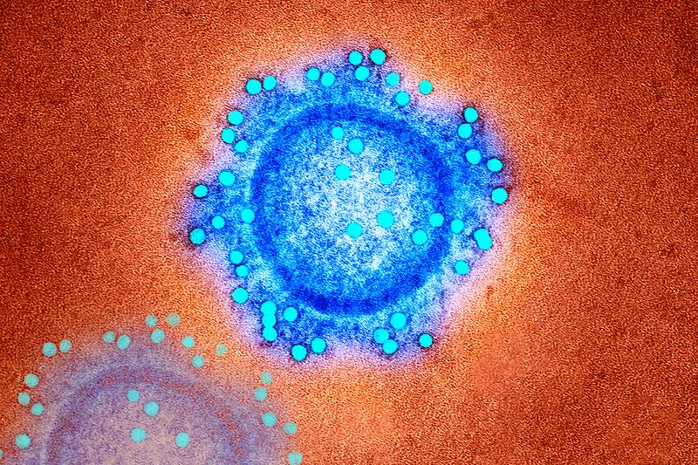
Logbook
General

Name: __________________________________
Teacher: Mrs Cunningham

Contents Page
Page # | Description

CHECK POINTS

☐ | Week 14 | Select issue and identify relevant scientific concepts for research
☐ | Week 14 | Identify sources and conduct research
☐ | Week 14 | Submit draft infographic for feedback
☐ | Week 15 | Submit final infographic

Authentication strategies:
The teacher will:
- provide class time for task completion.
- monitor progress at specified check points.
- collect and annotate drafts.

The student will:
- maintain a logbook / journal to document their progress.
- acknowledge all sources.

Issue options:
Issue 1: Declining fertility rates – why is it happening, is this a problem and what can be done about it?
Declining fertility rates and the threat to human rights.
https://www.ibanet.org/Declining-fertility-rates-and-the-threat-to-human-rights
Issue 2: ART derived unused embryos – choices and ethics
What happens to the excess unused embryos after an IVF treatment?
https://www.invitra.com/en/surplus-embryos-after-an-in-vitro-fertilization/
Issue 3: ART availability and the Law in Western Australia
Independent Review of the Human Reproductive Technology Act 1991 and the Surrogacy Act 2008 https://www.health.wa.gov.au/Articles/S_T/Submissions-for-HRT-review

Part A: Background Research
Chosen issue option:
____________________________________________________________________________________________________________________________________________________________________________________
Reason for selecting the above issue option:
____________________________________________________________________________________________________________________________________________________________________________________________________________________________________________________________________________________________________________________________________________________________________________________________________________________________________Research questions you need to ask yourself:
________________________________________________________________________________________________________________________________________________________________________________________________________________________________________________________________________________________________________________________________________________________________________________________________________________________________________________________________________________________________________________________________________________________________________________________________________________________________________________________________________________________________________________________________________________________________________________________________________________________________________________________________________
Reliable source 1 information to answer research questions (use the one provided)
____________________________________________________________________________________________________________________________________________________________________________________________________________________________________________________________________________________________________________________________________________________________________________________________________________________________________________________________________________________________________________________________________________________________________________________________________________________________________________________________________________________________________________________________________________________________________________________________________________________________________________________________________________________________________________________________________
________________________________________________________________________________________________________________________________________________________________________________________________________________________________________________________________________________________________________________________________________________________________________________________________________________________________________________________________________________________________________________________________________________________________________________________________________________________________________________________________________________________________________________________________________________
Reference for reliable source 1 (the one provided):
________________________________________________________________________________________________________________________________________________________________________________________________________________________________________________
Reliable source 2 information to answer research questions (you need to find another one yourself to use to gather information):
____________________________________________________________________________________________________________________________________________________________________________________________________________________________________________________________________________________________________________________________________________________________________________________________________________________________________________________________________________________________________________________________________________________________________________________________________________________________________________________________________________________________________________________________________________________________________________________________________________________________________________________________________________________________________________________________________
________________________________________________________________________________________________________________________________________________________________________________________________________________________________________________________________________________________________________________________________________________________________________________________________________________________________________________________________________________________________________________________________________________________________________________________________________________________________________________________________________________________________________________________________________________________________________________________________________________________________________________________________________
Reference for reliable source 2 (the one you found yourself to gather information):
________________________________________________________________________________________________________________________________________________________________________________________________________________________________________________
Research the chosen issue option related to male and female reproductive systems:
________________________________________________________________________________________________________________________________________________________________________________________________________________________________________________________________________________________________________________________________________________________________________________________________________________________________________________________________________________________________________________________________________________________________________________________________________________________________________________________________________________________________________________________________________________________________________________________________________________________________________________________________________________________________________________________________________________________________________________________________________________________________________________________________________________________________________________________________________________________________________________________________________________________________________________________________________________________________________________________________________________________________________________________________________________________________________________________________________________________________________________________________________________________________________________________________________________________________________________________________________________________________________________________________________________________________________________________________________________________________________________________________________________________________________________________________________________________________________________________________________________________________________________________________________________________________________________________________________________________________________________________________________________________________________________________________________________________________________________________________________________________________________________________________________________________________________________________________________________________________________________________________________________________________________________________________________________________________________________________________________________________________________________________________________________________________________________________________________________________________________________________________________________________________________________________________________________________________________________________________________________________________________________________________________________________________________________________________________________________________________________________________________________________________________________________________________________________________________________________________________________________________________________________________________________________________________________________________________________________________________________________________________________________________________________________________________________________________________________________________________________________________________________________________________________________________________________________________________________________________________________________________________________________________________________________________________________________________________________________________________________________________________________________________________________________________________________________________________________________________________________________________________________________________________________________________________________________________________________________________________________________________________________________________________________________________________________________________________________________________________________________________________________________________________________________________________________________________________________________________________________________________________________________________________________________________________________________________________________________________________________________________________________________________________________________________________________________________________________________________________________________________________________________________________________________________________________________________________________________________________________________________________________________________________________________________________________________________________________________________________________________________________________________________________________________________________________________________________________________________________________________________________________________________________________________________________________________________________________________________________________________________________________________________________________________________________________________________________________________________________________________________________________________________________________________________________________________________________________________________________________________________________________________________________________________________________________________Research the relevant scientific concepts associated with the issue chosen:
____________________________________________________________________________________________________________________________________________________________________________________________________________________________________________________________________________________________________________________________________________________________________________________________________________________________________________________________________________________________________________________________________________________________________________________________________________________________________________________________________________________
________________________________________________________________________________________________________________________________________________________________________________________________________________________________________________________________________________________________________________________________________________________________________________________________________________________________________________________________________________________________________________________________________________________________________________________________________________________________________________________________________________________________________________________________________________________________________________________________________________________________________________________________________________________________________________________________________________________________________________________________________________________________________________________________________________________________________________________________________________________________________________________________________________________________________________________________________________________________________________________________________________________________________________________________________________________________________________________________________________________________________________________________________________________________________________________________________________________________________________________________________________________________________________________________________________________________________________________________________________________________________________________________________________________________________________________________________________________________________________________________________________________________________________________________________________________________________________________________________________________________________________________________________________________________________________________________________________________________________________________________________________________________________________________________________________________________________________________________________________________________________________________________________________________________________________________________________________________________________________________________________________________________________________________________________________
Research the impact of the issue on mental and/or physical health (male/female):
____________________________________________________________________________________________________________________________________________________________________________________________________________________________________________________________________________________________________________________________________________________________________________________________________________________________________________________________________________________________________________________________________________________________________________________________________________________________________________________________________________________________________________________________________________________________________________________________________________________________________________________________________________________________________________________________________________________________________________________________________________________________________________________________________________________________________________________________________________________________________________________________________________________________________________________________________________________________________________________________________________________________________________________________________________________________________________________________________________________________________________________________________________________________________________________________________________________________________________________________________________________________________________________________________________________________________________________________________________________________________________________________________________________________________________________________________________________________________________________________________________________________________________________________________________________________________________________________________________________________________________________________________________________________________________________________________________________________________________________________________________________________________________________________________________________________________________________________________________________________________________________________________________________________________________________________________________________________________________________________________________________________________________________________________________________________________________________________________________________________________________________________________________________________________________________________________________________________________________________________________________________________________________________________
Research any impacts the issue may have on society:
____________________________________________________________________________________________________________________________________________________________________________________________________________________________________________________________________________________________________________________________________________________________________________________________________________________________________________________________________________________________________________________________________________________________________________________________________________________________________________________________________________________________________________________________________________________________________________________________________________________________________________________________________________________________________________________________________________________________________________________________________________________________________________________________________________________________________________________________________________________________________________________________________________________________________________________________________________________________________________________________________________________________________________________________________________________________________________________________________________________________________________________________________________________________
Additional research information:
____________________________________________________________________________________________________________________________________________________________________________________________________________________________________________________________________________________________________________________________________________________________________________________________________________________________________
Part B: Draft project
An information graphic or ‘infographic’ is a visual communication genre that combines common icons, illustrations, minimal text, data visualisations, and information, to create an engaging narrative.
An infographic simplifies a large amount of complex information into primarily visual messages, so an audience can read and understand them with ease. The simplicity of a science infographic can be helpful in communicating information to non-academic audiences through news articles, brochures, or posters; however, scientists can also use infographics to communicate their research with peers without the formalities of a journal article.
An infographic can:
- inform
- entertain
- persuade an audience e.g. to take a certain action
- be a visual explanation of something
Once you have identified the topic of your infographic:
- Review existing infographics for that topic (there will probably be lots available)
- Look at what does and doesn’t work
- Consider how you could present your topic from a unique or unexpected angle, or by focussing on something the audience might not already know
- Good information is the foundation layer of a good infographic.
- Too much information will overwhelm you and your audience; when researching your topic, keep the key message and aims of your infographic in mind. Review and discard information that will not help you tell your story relative to your focus.
- Any combination of data visualisations (graphs), icons, and graphics (images and illustration) can make up your design, but remember the focus is the images and not the text.
Example infographics:
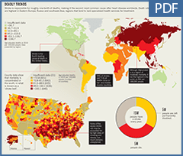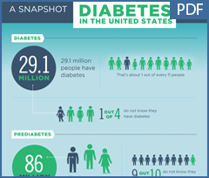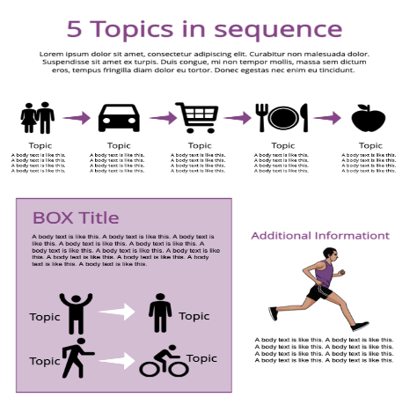
Style of infographic used to present the information:
__________________________________________________________________________________________________________________________________________Planned timeline to complete the project:
_______________________________________________________________________________________________________________________________________________________________________________________________________________________________________________________________________________________________________________________________________________________________________________________________________________________________________________________________________________________________________________________________________________________________________________________________________________________________________________________________________________________________________________________________________________________________________________________
‘Must have’ information to include:
Audience and key focus.
____________________________________________________________________________________________________________________________________________________________________________________________________________________________________________________________________________________
Aim – raise awareness or other purpose.
_______________________________________________________________________________________________________________________________________________________________________________________________________________ Key/core message or focus for the infographic. ____________________________________________________________________________________________________________________________________________________________________________________________________________________________________________________________________________________
Introduction – how will you grab the attention of audience and explain what infographic is about.
____________________________________________________________________________________________________________________________________________________________________________________________________________________________________________________________________________________________________________________________________________________________________________________________________________________________________________________________________________________________________________________________________________________________________________________________________________________________________________________________________________________________________________________________________________________________________________________________________________________________________________________________
Body – contains bulk of your information and evidence
_____________________________________________________________________________________________________________________________________________________________________________________________________________________________________________________________________________________________________________________________________________________________________________________________________________________________________________________________________________________________________________________________________________________________________________________________________________________________________________________________________________________________________________________________________________________________________________________________________________________________________________________________________________________________________________________________________________________________________________________________________________________________________________________________________________________________________________________________________________________________________________________________________________________________________________________________________________________________________________________________________________________________________________________________________________________________________________________________________________________________________________________________________________________________________________________________________________________________________________________________________________________________________________________________________________________________________________________________________________________________________________________________________________________________________________________________________________________________________________________________________________________________________________________________________________________________________________________________________________________________________________________________________________________________________________________________________________________________________________________________________________________________________________________________________________________________________________________________________________________________________________________________________________________________________________________________________________________________________________________________________________________________________________________________________________________________________________________________________________________________________________________________________________________________________________________________________________________________________________________________________________________________________________________________________________________________________________________________________________________________________________________________________________________________________________________________________________________________________________________________________________________________________________________________________________________________________________________________________________________________________________________
Conclusion – indicates what audience is meant to take from the infographic
____________________________________________________________________________________________________________________________________________________________________________________________________________________________________________________________________________________________________________________________________________________________________________________________________________________________________________________________________________________________________________________________________________________________________________________________________________________________________________________________________________________________________________________________________________________________________________________________________________________________________________________________________________________________________________________________________________________________________________________________________________________________________________________________________________________________________________________________________________________________________________________________________________________________________________________________________________________________________________________________________________________________________________________________________________________________________
Where are you adding supporting scientific evidence?
__________________________________________________________________________________________________________________________________________________________________________________________________________________________________________________________________________________________________________________________________________________________________________________________________________________________________________________________________________________________________________________________________________________________________________________________________________________________________________________________________________________________________________________
Questions for your teacher:
__________________________________________________________________________________________________________________________________________________________________________________________________________________________________________________________________________________________________________________________________________________________________________________________________________________________________________________________________________________________________________________________________________________________________________________________________________________________________________________________________________________________________________________________________________________________________________________________________________________________________________________________________________________________________________________________________________________________________________________________________________________________________________________________________________________________________________________________________________________________________________________________________________________________________________________________________________________________
DO NOT WRITE HERE – Teachers Comments:
________________________________________________________________________________________________________________________________________________________________________________________________________________________________________________________________________________________________________________________________________________________________________________________________________________________________________________________________________________________________________________________________________________________________________________________________________________________
Part C: Final project
Changes you need to make from the feedback:
____________________________________________________________________________________________________________________________________________________________________________________________________________________________________________________________________________________________________________________________________________________________________________________________________________________________________________________________________________________________________________________________________________________________________________________________________________________________________________________________________________________
____________________________________________________________________________________________________________________________________________________________________________________________________________________________________________________________________________________________________________________________________________________________________________________________________________________________________________________________________________________________________________________________________________________________________________________________________________________________________________________________________________________
________________________________________________________________________________________________________________________________________________________________________________________________________________________________________________
References used in the final project:
____________________________________________________________________________________________________________________________________________________________________________________________________________________________________________________________________________________________________________________________________________________________________________________________________________________________________________________________________________________________________________________________________________________________________________________________________________________________________________________________________________________
________________________________________________________________________________________________________________________________________________________________________________________________________________________________________________________________________________________________________________________________________________________________________________________________________________________________________________________________________________________________________________________________________________________________________________________________________________________________________________________________________________________________________________________________________________________________________________________________________________________________________________________________________________________________________________________________________________________________________________________________

